**Week 2 – S2 – Practise Problem Solution**

**Name: Ramesh Harisabapathi Chettiar**

**Roll Number: RA2411030010263**

**Course: Networking and Communications**

**Semester: 3**

**Date of Submission: 23/08/2025**

**PRACTICE PROBLEM 1: (Any 4)**

**Built-In String Methods - Basic Operations**

**Task: Create a program that demonstrates common String methods for text analysis and**

**manipulation.**

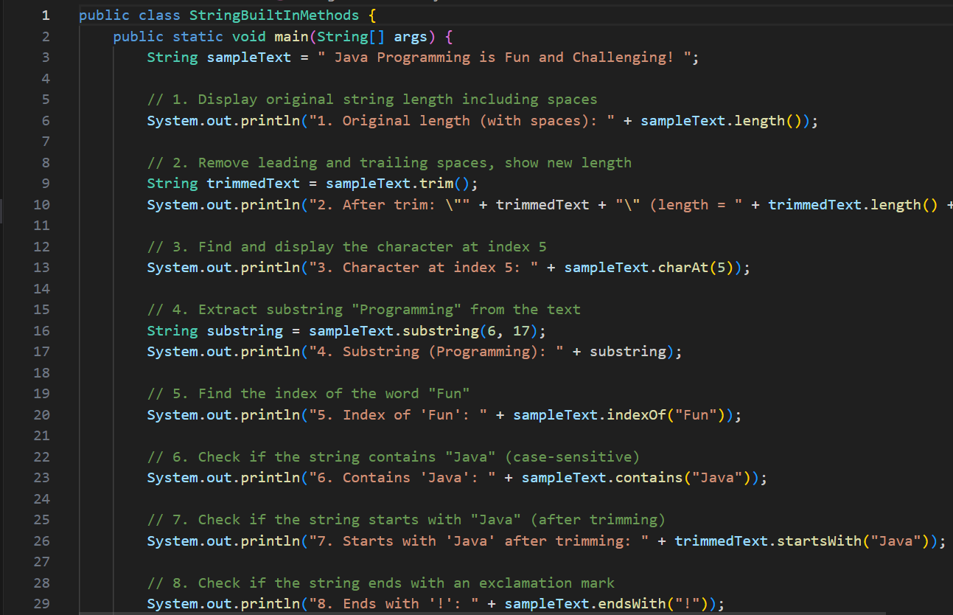 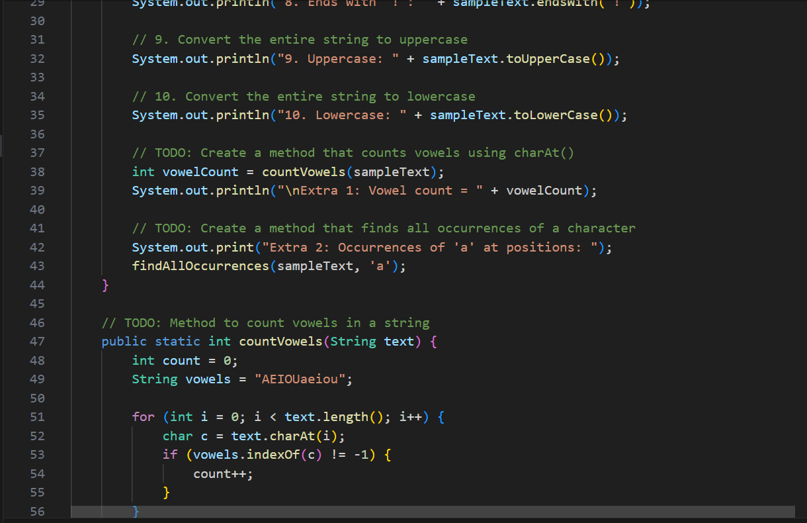 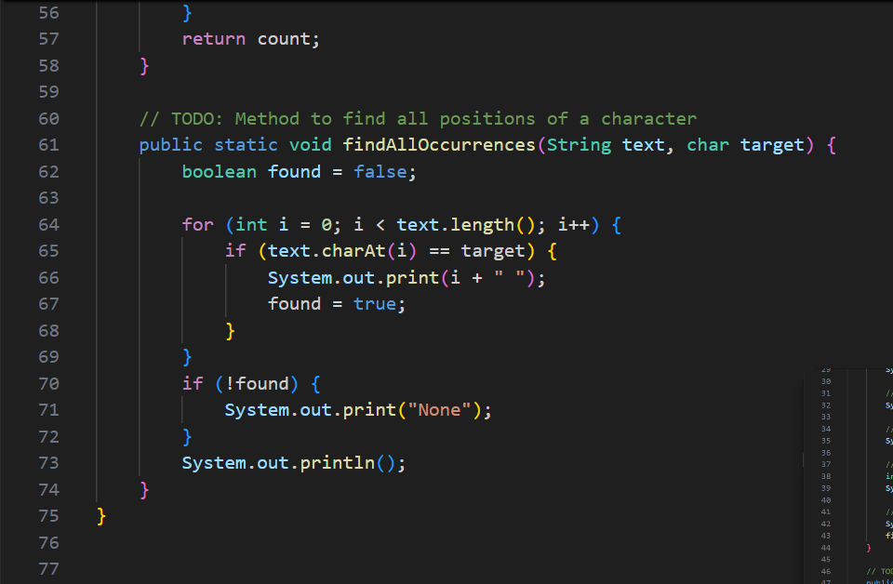

**OUTPUT🡪** 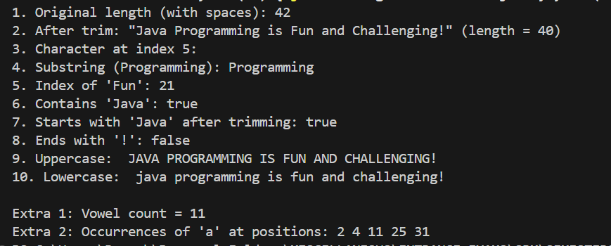

**🛠 PRACTICE PROBLEM 2:**

**String Manipulation Methods**

**Task: Create a text processing utility that uses various string manipulation methods.**

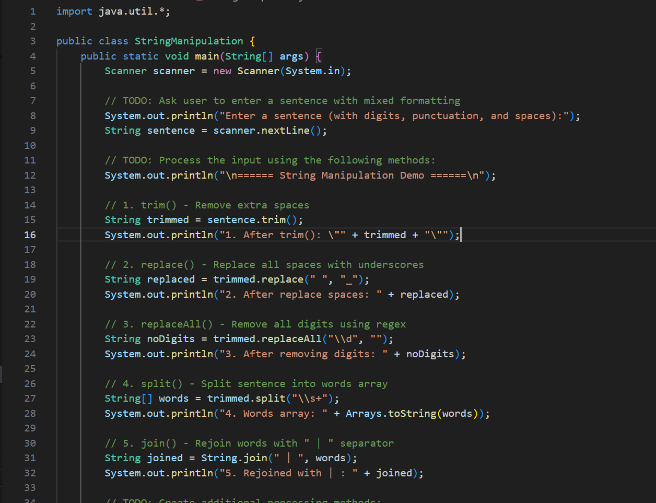 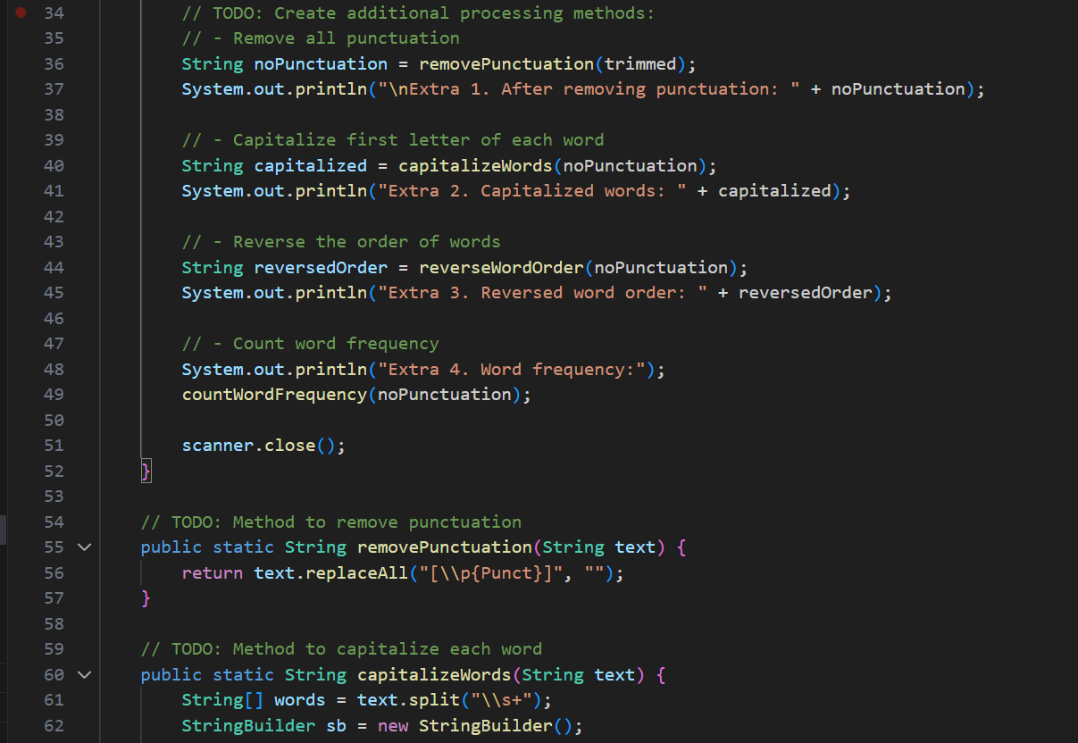 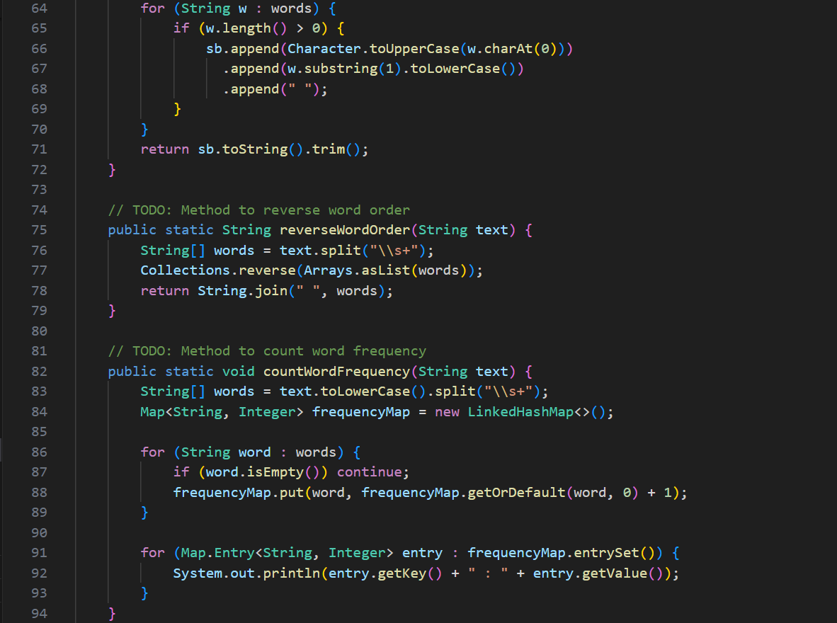

**OUTPUT🡪**  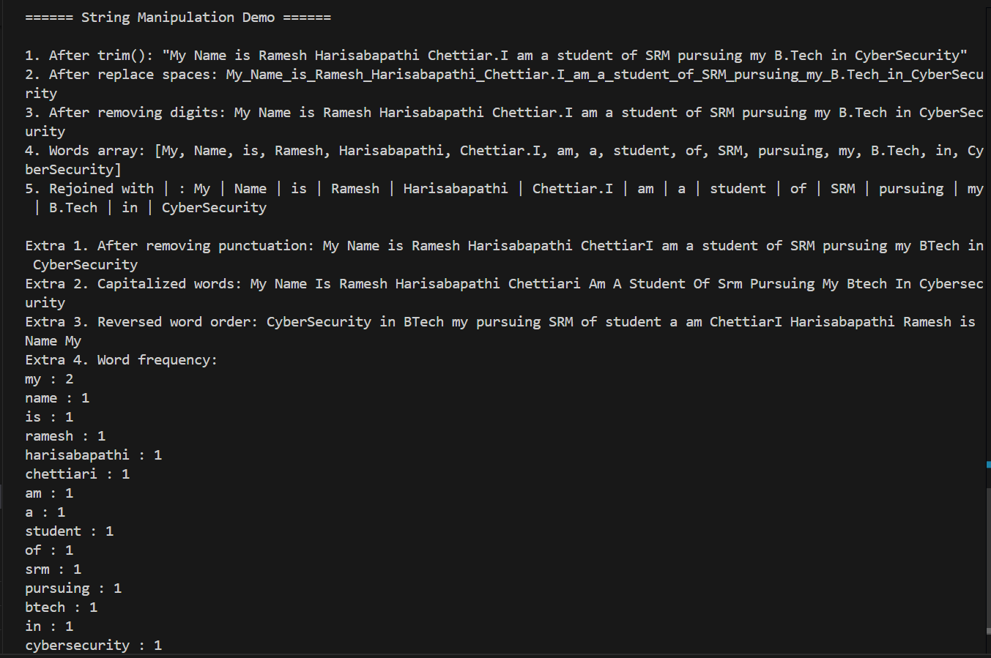

**🛠 PRACTICE PROBLEM 3:**

**ASCII Codes and Character Conversion**

**Task: Create a program that demonstrates ASCII character manipulation and conversion.**

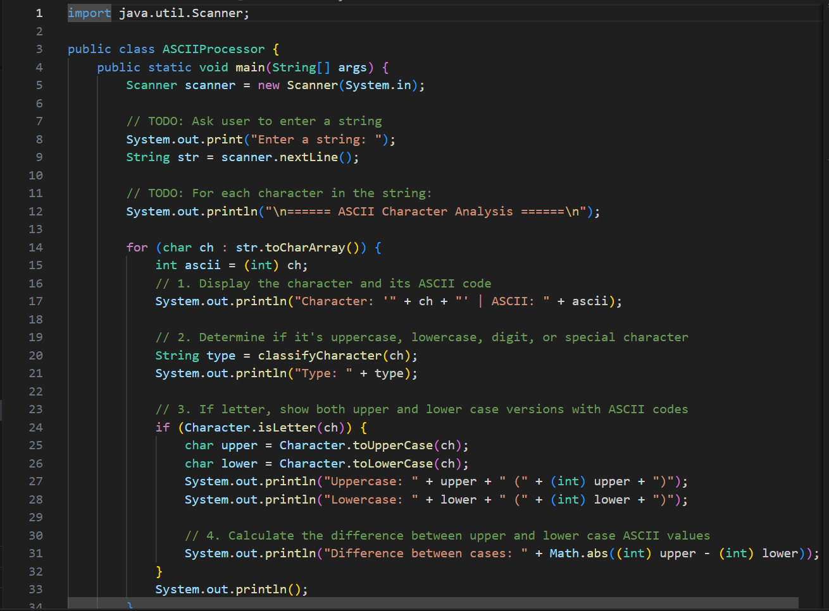 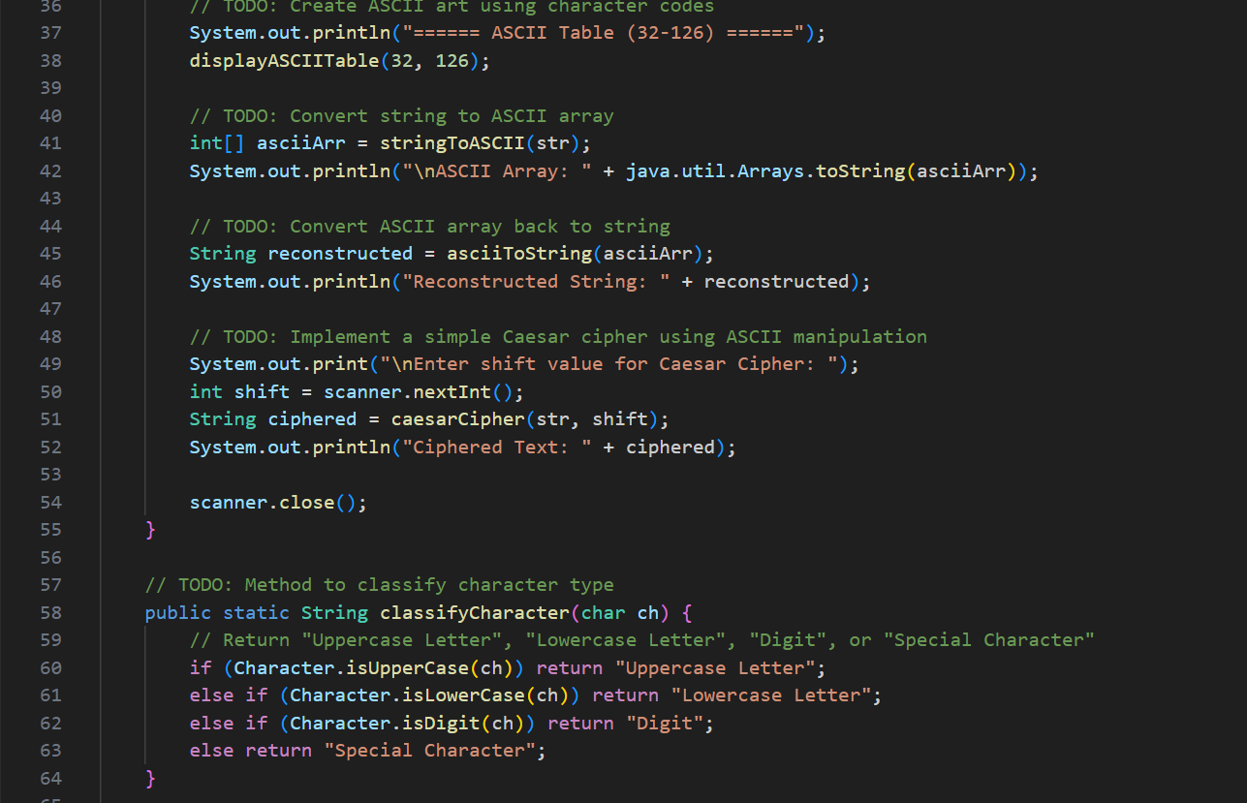 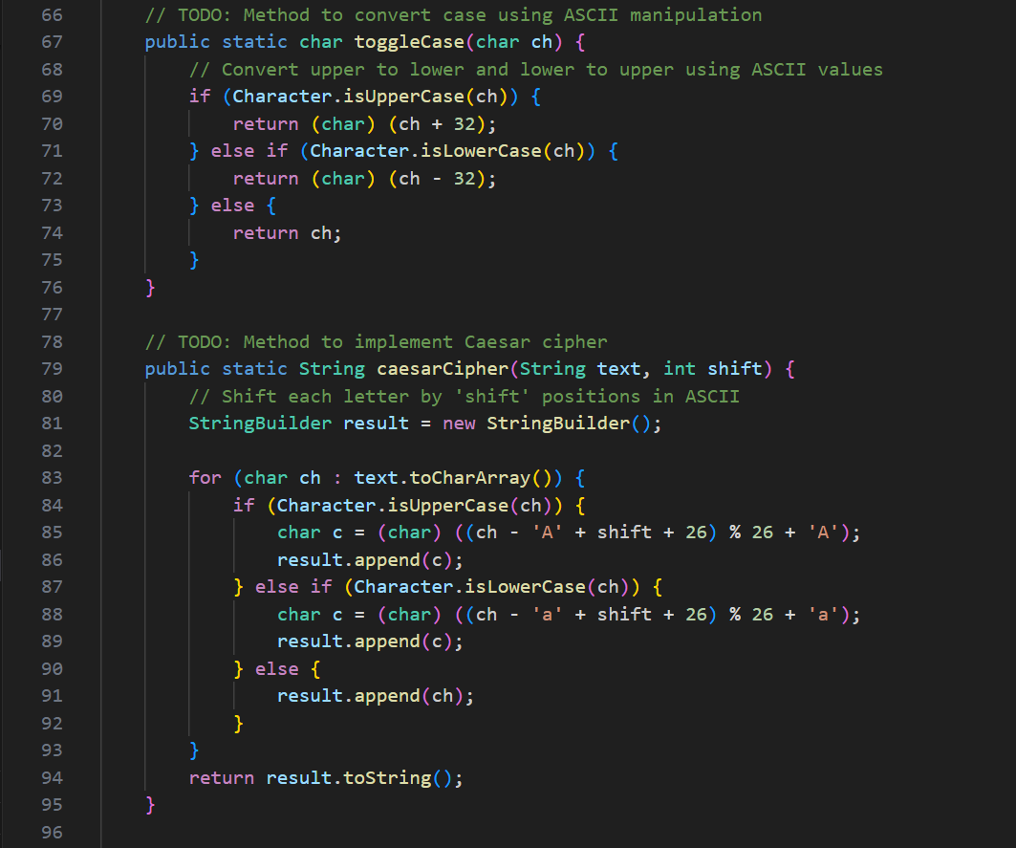 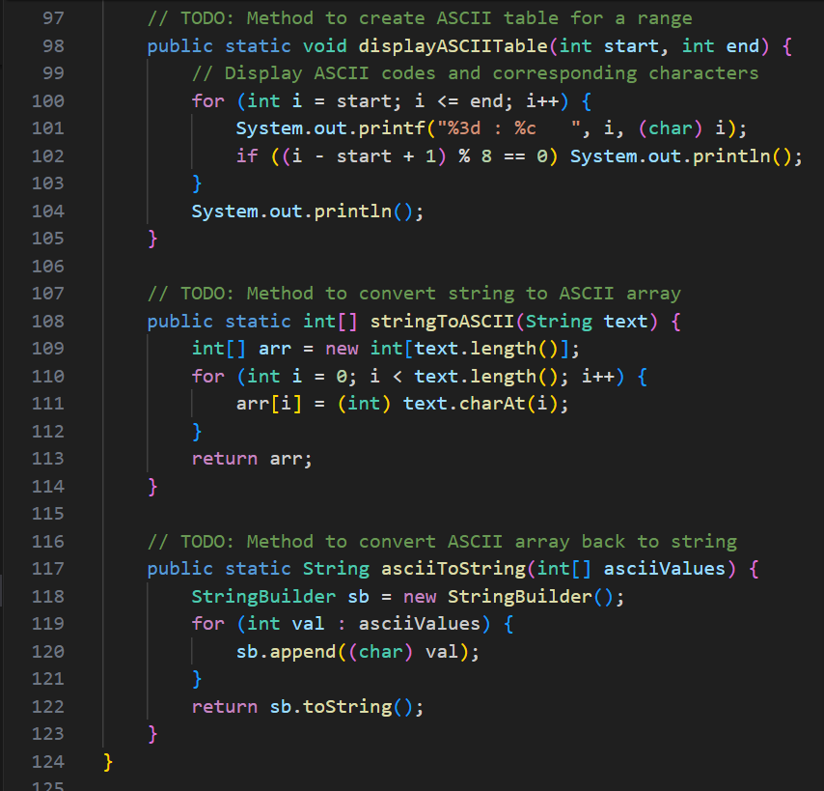

OUTPUT🡪 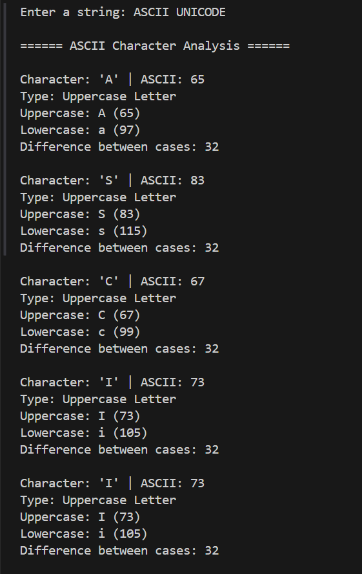  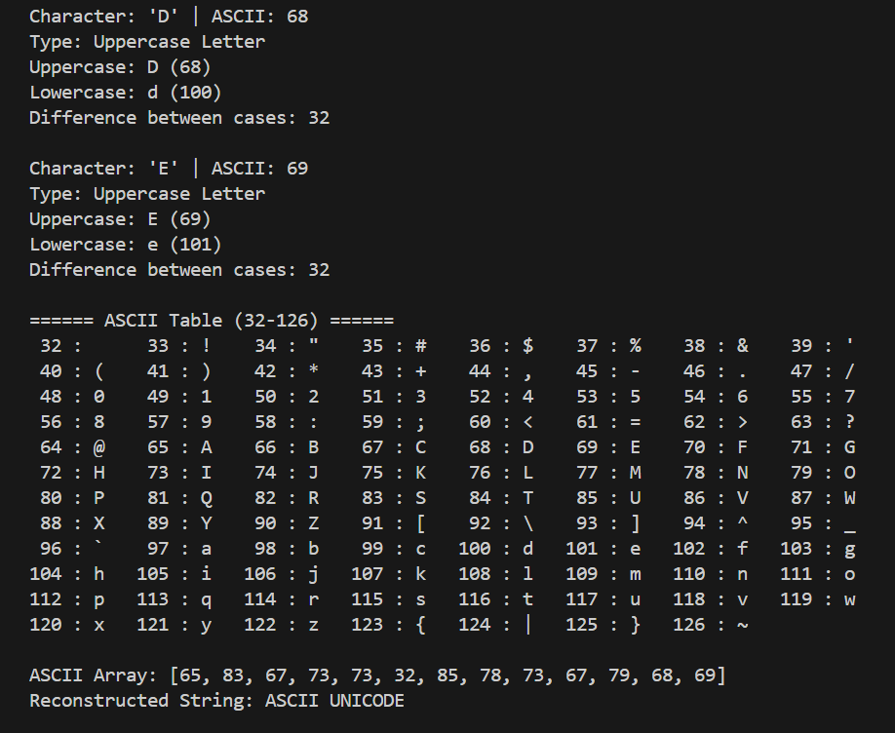

**🛠 PRACTICE PROBLEM 4:**

**StringBuilder, StringBuffer, and Performance**

**Task: Create a performance comparison program that demonstrates the differences between**

**String, StringBuilder, and StringBuffer.**

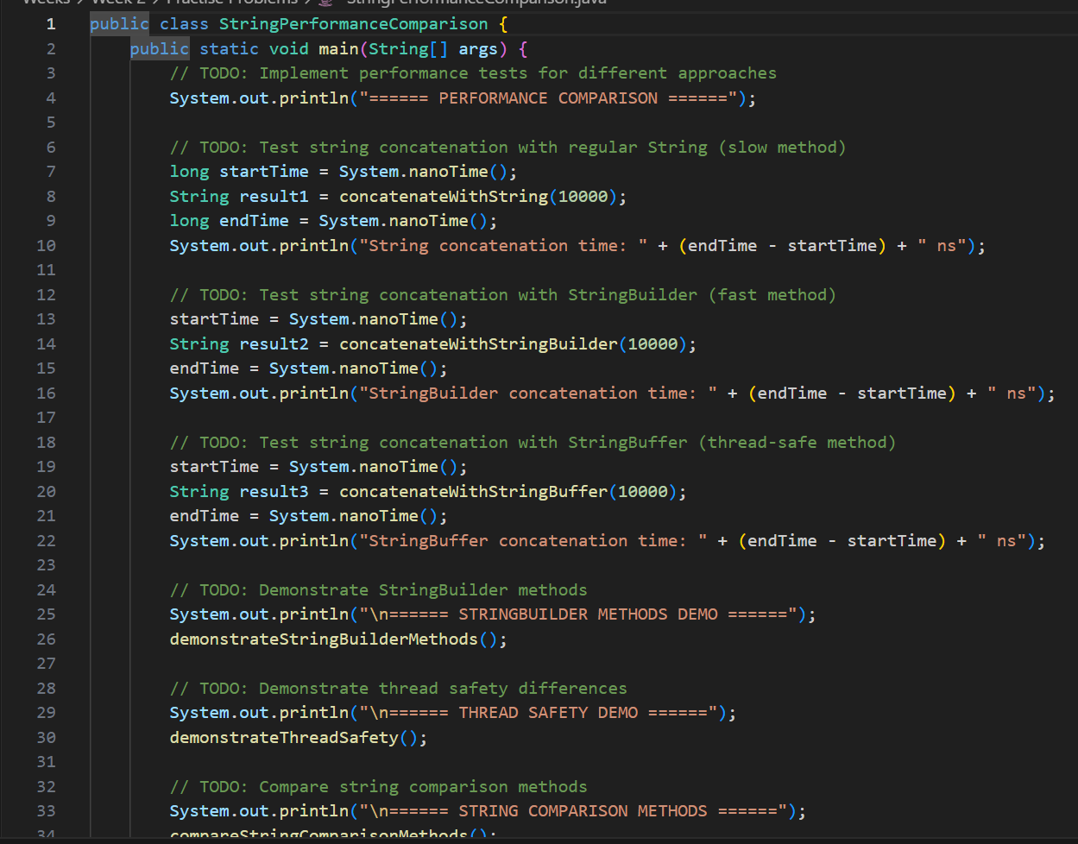 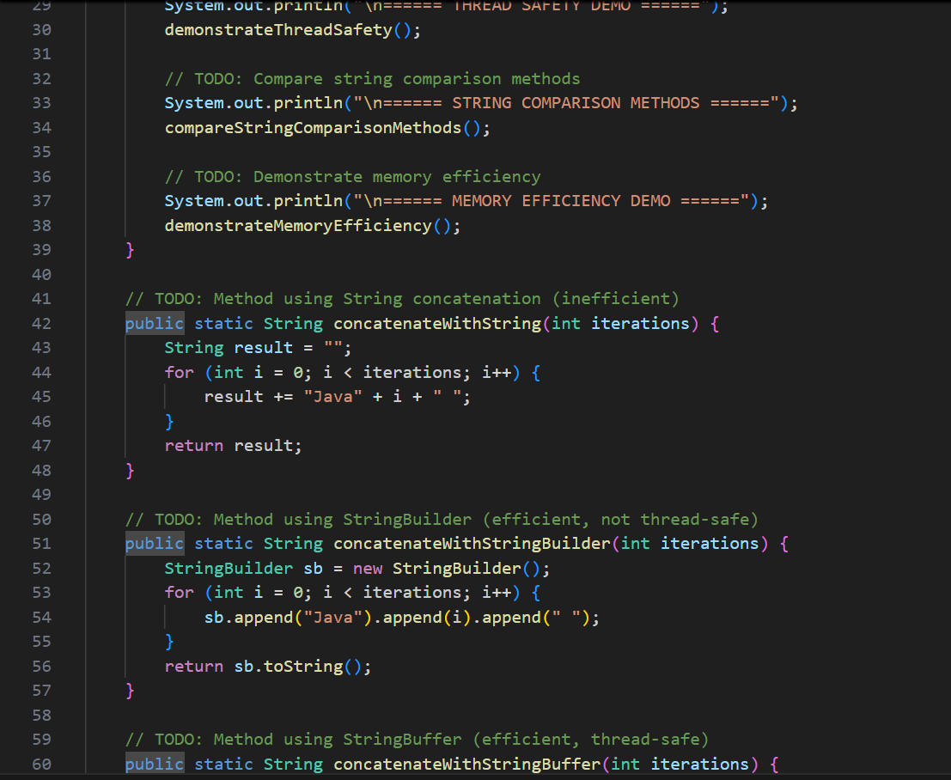 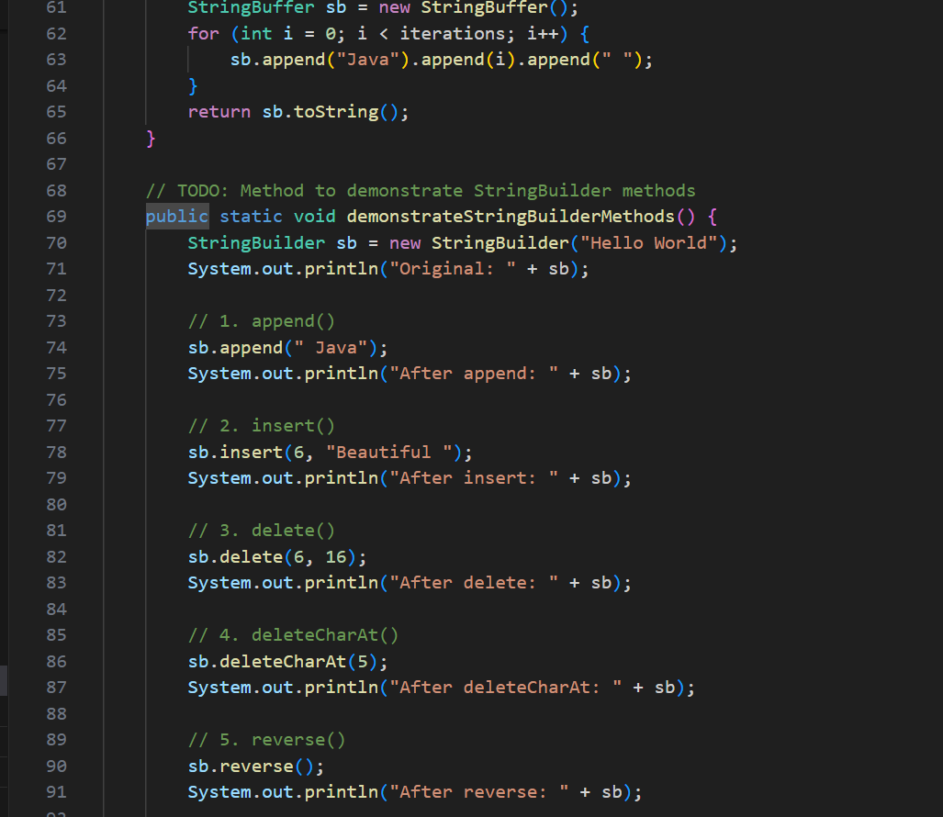 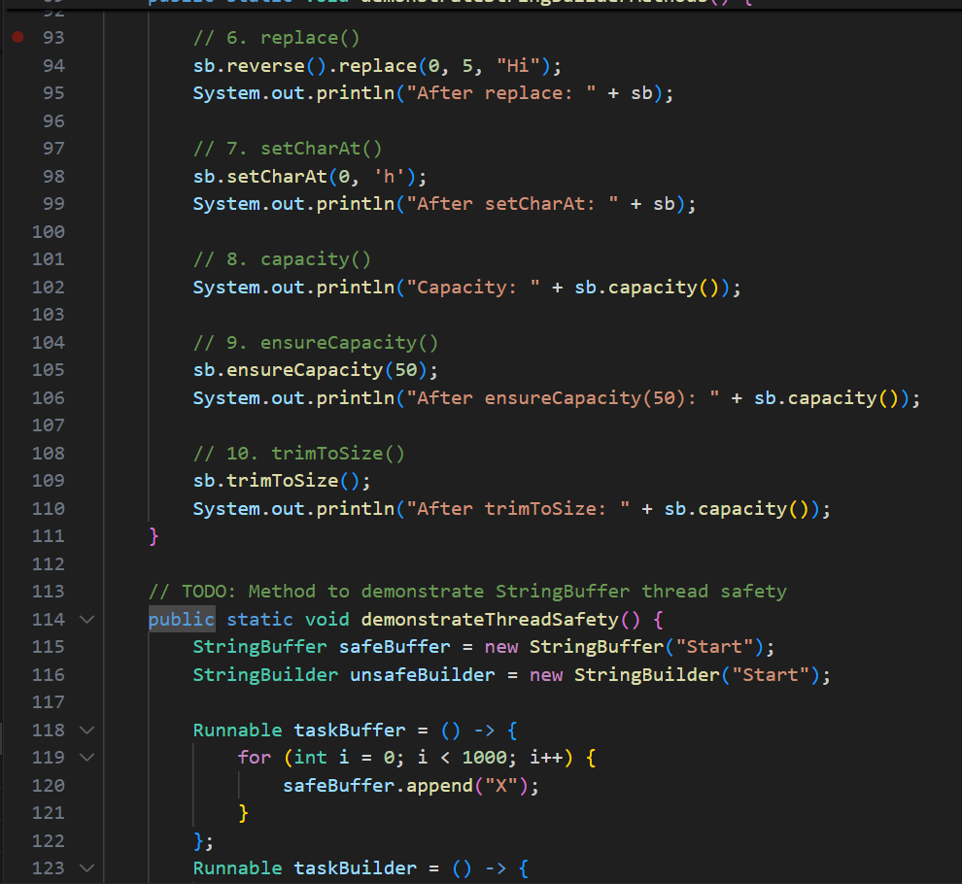 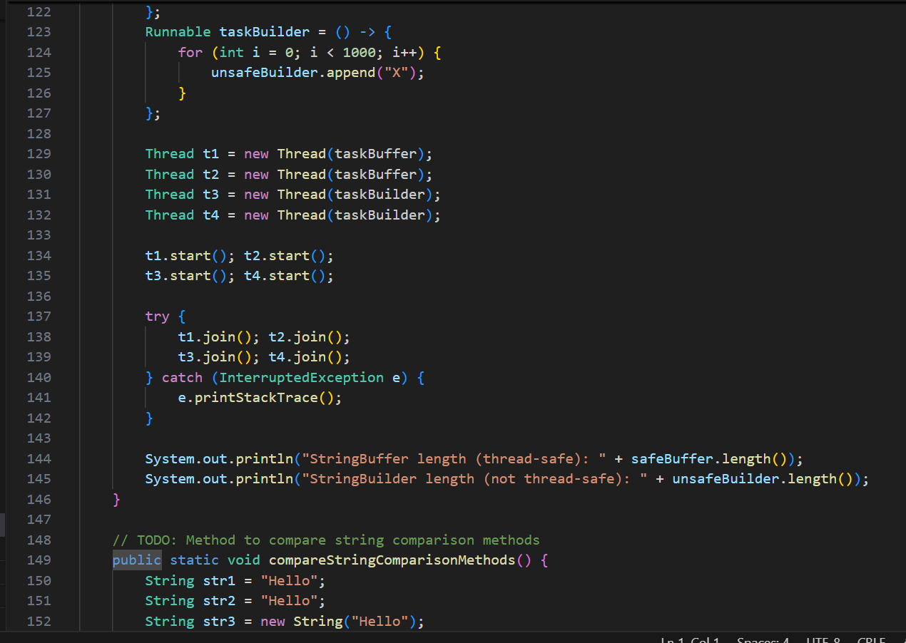 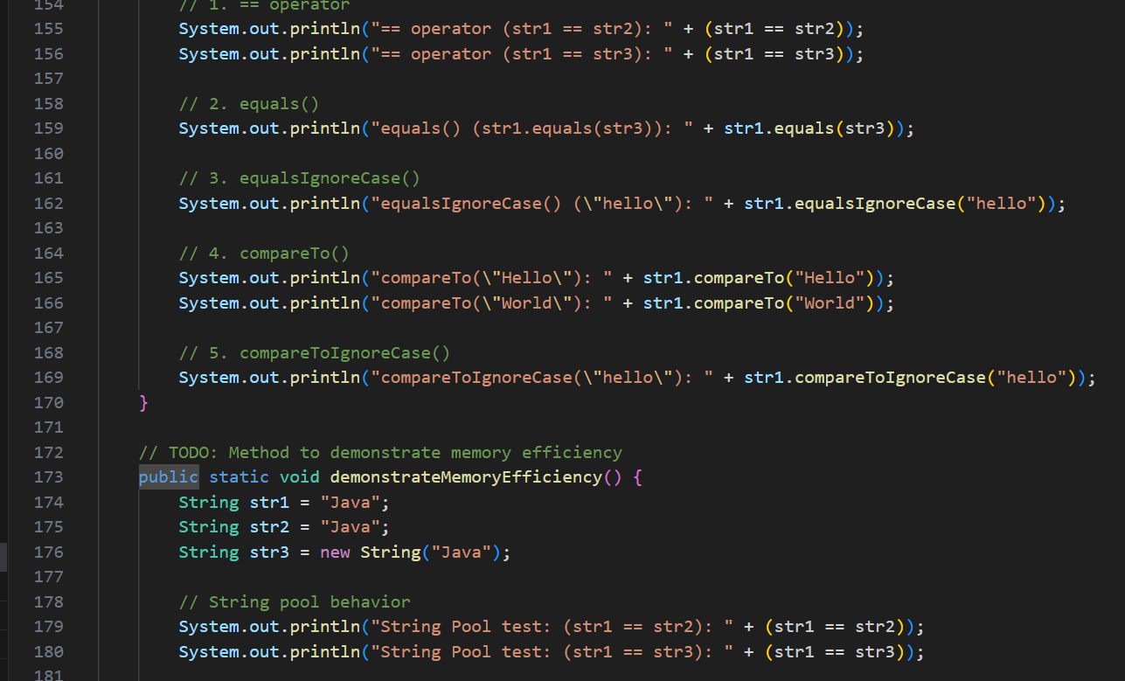

**OUTPUT🡪** 